One does not live on bread alone, but on every word that comes forth from the mouth of God. Matthew 4:4
On a hillside by the Sea of Galilee, Jesus taught his disciples the only prayer he would teach. It is deceptively simple and familiar enough that most Christians may not even notice the words as they rattle them off. The last line asks that God keep us from temptation and deliver us from evil.
Temptation is a human experience, in and of itself, not inherently problematic. Scripture makes a deliberate point to let us know that Jesus himself was tempted. As he prepared for his ministry in prayer and fasting alone in the desert, Satan set before Jesus the same things that may tempt us: power, glory and the illusion of control. Jesus rebukes him each time, quoting Scripture and affirming over and again the power and glory of God.
We are not often tempted to turn stones into bread or command angels, our temptations are more subtle. In C.S. Lewis’ book The Screwtape Letters, a senior demon, Screwtape, is writing to his nephew, a junior tempter named Wormwood. Screwtape steers his protégé away from more flamboyant temptations. He writes, “Indeed the safest road to Hell is the gradual one--the gentle slope, soft underfoot, without sudden turnings, without milestones, without signposts. Your affectionate uncle, Screwtape.”
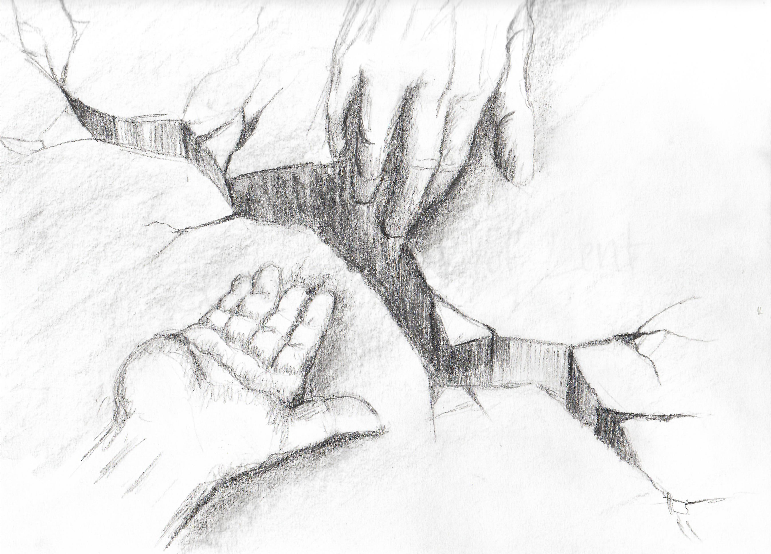
Our greatest temptations and most dangerous temptations are not spectacularly sinful, they are cumulatively destructive. Little by little we buy into the belief that by doing, buying or achieving we can add to our own value, dignity and worth. Little by little we convince ourselves that some small thing isn’t that big of a deal.
So we listen to or share what we overheard about someone. We groom and fret and fuss about how our external appears without paying attention to the health of our minds, hearts and spirits. We treat ourselves with extra food and goods without considering those who don’t have the essentials. We focus on what the world has to say about us, forgetting that God has already called us good and beloved. And so it goes, the small cracks become chasms that in time become false separations from others and the love of God.
Lent invites us again to recall that we are fearfully and wonderfully made by God in whose words and love we find our truest life.
What daily temptation is the most challenging for you?

