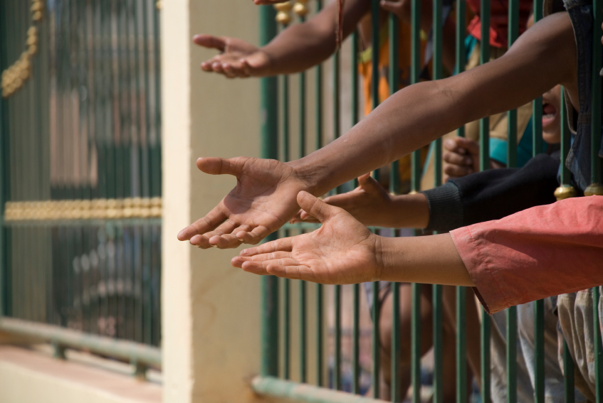
On this day, we contemplate what it means to be part of one human family, we acknowledge those who work to eliminate the inequalities of our world and we reflect on the meaning of global justice and human dignity.

Our human family is comprised of many different cultures, languages, races, traditions and beliefs. God calls us to recognize that our differences create the unique fabric of the whole human family. We are connected by the human dignity that is innate in every human person. The World Day of Social Justice reminds us of the guiding practices that provide the backbone for peace and equality throughout the world.

Please take a moment of reflection to consider the following:

- Do I see any injustices in my daily life and my own thinking?
- Do I go out of my way to make a difference in the lives of those who are not as fortunate as I am?
- Do I actively try to learn about other cultures and traditions?

Prayer: As a human family, we struggle with acknowledging and accepting our differences. We see hatred and violence that arise from our failure to recognize the dignity of every human person. Help us to see the injustices happening in our world today. Help us to recognize our own biases and faults. Guide us to be solutions to the problem, beginning with our own lives. Amen.

Please take a moment of reflection to consider the following:

- Do I take time to pray for the global community and the injustices at large?
- Do I educate myself on the issues of injustice in the global community?
- Do I work to combat the language of hate in conversations regarding social justice?

Prayer: O God, while many of the global issues seem out of our hands, help us to see the role we play in the global fight for social justice. Through the transformative power of prayer, you give us the ability to partake in issues that are worlds away. Help us to be aware of the injustices in the world by paying better attention to the suffering of our brothers and sisters. Help us to remember their needs and the needs of all those who work for social justice.
Amen.
Related sites:

http://www.un.org/en/events/socialjusticeday/

http://www.usccb.org/about/international-justice-and-peace/index.cfm

