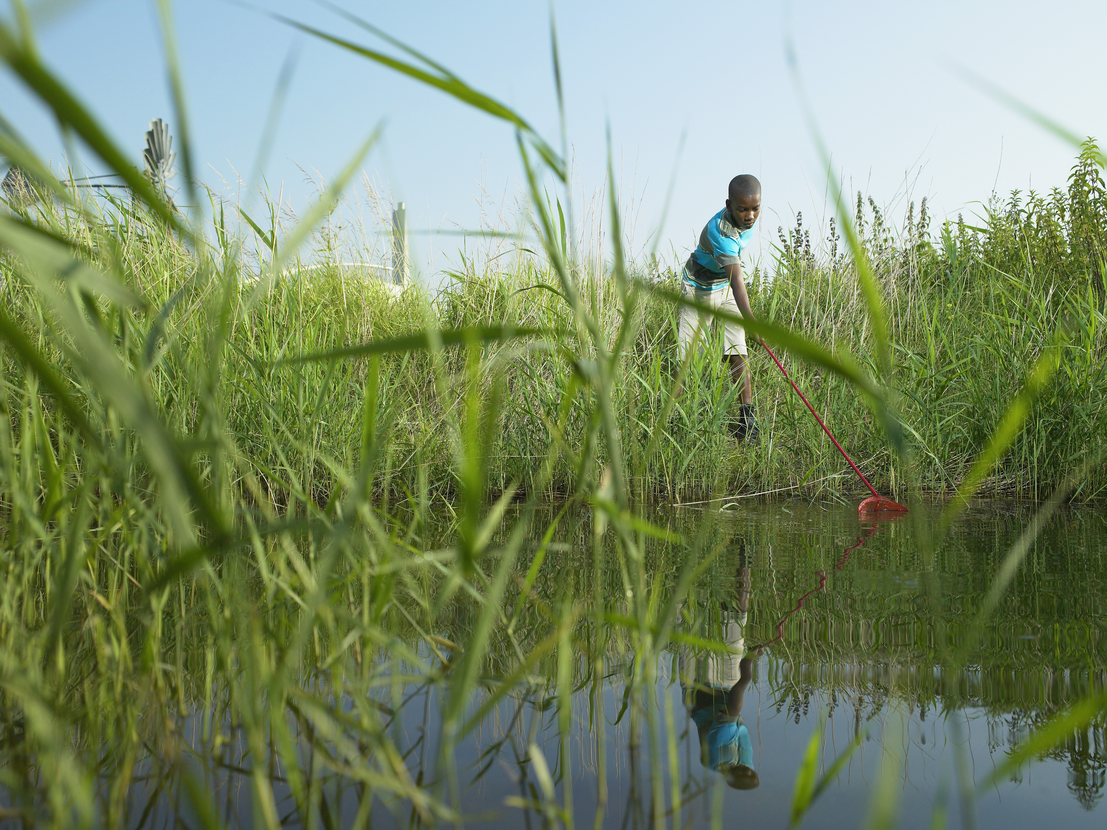
  - Opening Prayer
God of living water, you nourish and bring abundance to the bodies of all. Give us a deep desire to support and lead our communities by reducing our environmental footprint on clean water. May we consider both individually and communally as the ministry of health care the sacredness of our planet and the singular life-giving powers of water. We ask this in your holy name.

  - Reading
Water invites us to reflect on our origins. The human body is mostly composed of water, and many civilizations throughout history arose near great rivers that marked their identity. In an evocative image, the beginning of the book of Genesis states that, in the beginning, the spirit of the Creator “swept over the face of the waters.”

In considering the fundamental role of water in creation and in human development, I feel the need to give thanks to God for “Sister Water”, simple and useful for life like nothing else on our planet. Precisely for this reason, care for water sources and water basins is an urgent imperative. Today, more than ever, we need to look beyond immediate concerns and beyond a purely utilitarian view of reality … We urgently need shared projects and concrete gestures that recognize that every privatization of the natural good of water at the expense of the human right to have access to this good, is unacceptable.
- Pope Francis, 2018 Message for the World Day of Prayer for Care of Creation

Reflection
The health care industry is a major water consumer. From cooling equipment, plumbing, landscaping, laundry and medical process rinses. One estimate suggests that on average, hospitals use 570 gallons of water per staffed bed, per day. To put this figure into perspective, consider that the average American citizen uses around 150 gallons of water per day; the average Briton, 44 gallons; the average African, just 5 gallons.

How can you work with leadership and others to reduce the water consumption in your health system?

How do you use water in your home? As a commodity, a given, or a gift of God’s love and precious resource?

Whatever our role, let us pray that God open our eyes to the impact health care has on water from our planet.

  - Closing Prayer
God of all understanding, you show us through the waters of baptism a new way of being in relationship with Jesus. The water you share is living water; let it refresh and invigorate us to find creative solutions to curb our water usage. Let the water you share renew in us a conviction to be champions of change; to voice a greater awareness and respect your gift of water. Amen.

Jennifer Silvis, “Hospitals Can Tap Into Savings Through Water Conservation” https://www.healthcaredesignmagazine.com/architecture/saving-water-saving-money/

