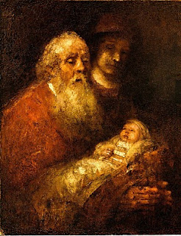
Christmas Day
December 25

The Gospel of Luke tells of a man in Jerusalem who is righteous and devout and takes the scriptures seriously. His greatest desire is to see the unfolding of God’s promise of salvation for Israel. And so the Holy Spirit reveals to him that he will not die before he has seen the Messiah of the Lord.
In the fullness of time, the Spirit leads Simeon, who has grown very old and feeble with waiting, to the temple where Mary and Joseph have come to present the infant Jesus to the Lord. Holding the baby tenderly in his arms, the old man sings a song of joy and praise:
“Lord, you now have set your servant free
to go in peace as you have promised;
For these eyes of mine have seen the Savior,
whom you have prepared for all the world to see:
A light to enlighten the nations, and the glory of your people Israel.”
Here is the promise made flesh, precious, held in the arms of one who, in T. S. Eliot’s words, “has eighty years and no to-morrow.” Simeon has glimpsed Salvation; he has held the Messiah in his arms.
It is Christmas. We behold the Child, our Savior. What are we to do with all this joy? Allan Chalmers tells us that the essence of happiness is “having something to do, something to love and something to hope for.” Another way of saying it is that happiness lies in our relationships—with God and our neighbors, our sisters and brothers.

Imagine a long-term care facility where an old man seated in a wheelchair yearns for his family’s visit. He holds a box of faded photographs in his lap; his gnarled hands tremble a bit as he lifts one image after another from the box. Although he has trouble recognizing the caregivers in this place, he recognizes each infant face. He remembers the circumstances of each child’s birth and the turning points of their lives. It is Christmas Day, and they are coming to visit. It feels as if he has been waiting a very long time. “Hi, Dad.” They are here, folding him in their loving arms.
Here we are at Christmas. The new year of the church has begun, and the cycle of the year will tell Jesus’ whole story—from birth in Bethlehem, to death on the cross, to glorious resurrection and the promise of the Second Coming. Our joy is like Simeon’s—we who have waited hold the child in our hearts and welcome him to live within us all year long.

The art offered with this reflection is Simeon with the Child in the Temple (1669) by Rembrandt van Rijn. The music, by Margaret Rizza, is “A Blessing.”

