Fourth Sunday of Advent
December 23, 2012
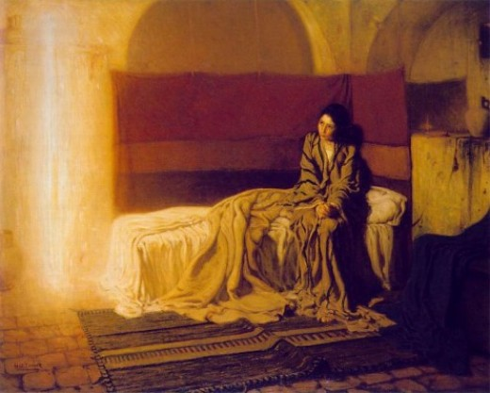
This is the fourth week of Advent, and as we light another candle, we are moving toward the great joy promised to us. We are almost there. We are making progress. We call out in the words of the Psalmist: “Restore us, O God of hosts; show the light of your countenance, and we shall be saved.”
Darkness blooms into light.
Warmth drives away the cold.

We inhale with expectation.
He is coming!
Prepare the way of the Lord!

Waiting in silence—we hear the song.
Waiting in darkness—we see the light.
Our new year has begun. The cycle of the seasons moves forward.
Our new selves begin to take shape.
We await the birth of the child—the Light of the World.

Inside the neo-natal unit, young parents hover over their tiny, fragile newborn. They look at his chest rise and fall, his heartbeats visible. Highly trained staff are attuned to the infant’s every need, every change in his vital signs. The whole hospital serves this tiny life—providing supplies, instruments and medicines. Laboratory, pharmacy, respiratory therapy, pastoral services—as a community of care they take part in giving hope, listening, helping to cope with the uncertainty. Even non-clinical areas serve and support this unseen family with professionalism and compassion.
And so it is—all are infinitely valuable, infinitely lovely in the eyes of God. Every person touched by Catholic health care reveals the image and likeness of God. Jesus, the unveiled face of God, will be born again among us. Joy is near.

The art offered with this reflection is The Annunciation (1898) by Henry Ossawa Tanner. The music, by Margaret Rizza, is “O, Give Thanks to the Lord.”

