Second Sunday of Advent
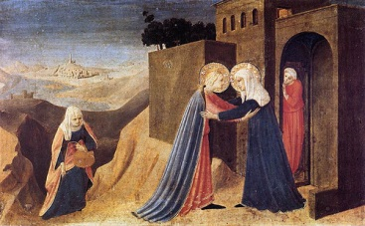
December 9, 2012

In the second week of Advent, we reflect upon the joyous reunion of the two kinswomen, Mary and Elizabeth. Mary has traveled to the hill country to the house of Zecharia and Elizabeth whose child will be known to the world
as John the Baptist. Each is aware that she is carrying a child of destiny.

At Mary’s greeting, Elizabeth feels her child leap in her womb. She welcomes Mary with the words that have become familiar to us in prayer: “Blessed are you among women, and blessed is the fruit of your womb.” The women cling to one another in mutual support. God has plans for great things to happen through them.

Mary’s response to Elizabeth is the great canticle we know as “The Magnificat.”
“My soul proclaims the greatness of the Lord,
My spirit rejoices in God my Savior; for he has looked with favor on his lowly servant.
From this day all generations will call me blessed: the Almighty has done great things for me, and holy is his Name.
He has mercy on those who fear him in every generation.
He has shown the strength of his arm, he has scattered the proud in their conceit.
He has cast down the mighty from their thrones, and has lifted up the lowly.
He has filled the hungry with good things, and the rich he has sent away empty.
He has come to the help of his servant Israel, for he has remembered his promise of mercy,
The promise he made to our fathers, to Abraham and his children forever.”
In Advent we sing our own songs of praise for the great things God has done for us and through us. We sing in thanks for the calling to serve in the ministry of health care—for there are many in our communities who need us.

Imagine a health clinic where children are receiving back-to-school physical exams and vaccinations. The boys and girls hide their anxiety by teasing each other and claiming not to be afraid of needles. The clinic nurse notices that one child’s shoes are too small and that another appears hungry. One little girl needs glasses, and a little boy has trouble hearing. There is so much to do for these children—so much is needed to assure them a healthy future.

God has plans for great things to happen through the work of our hands. John the Baptist called to the people to “make way” for the Lord who is coming. God calls to us, as God called to Mary and to Elizabeth: “Make way—and rejoice.”

The art offered with this reflection is The Visitation (1433) by Fra Angelico. The music, by Margaret Rizza, is “Magnificat.”

