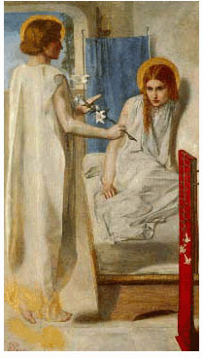
Third Sunday of Advent
December 16, 2012

In Advent we’re invited to trust, to wait, to listen, to be surprised and to be open to the Good News. Like Mary and her kinswoman Elizabeth, we rejoice and give thanks that God has plans for great things to happen through us. We are learning to not be afraid and to live fully while we await His coming.
The Angel of the Lord startled Zecharia with the news that he would be a father. Then he calmed the old man: “Do not be afraid. Your prayer has been heard. You will have joy and gladness.” At the Annunciation, Gabriel calmed Mary with the words, “Do not be afraid.” Mary’s Son Jesus assured his disciples, saying, “Be not afraid.”
Life is full of turning points—times when we can allow fear to take hold or we can turn to God for help and comfort. Imagine the exam room in an emergency department. A woman lies on the exam table waiting for the results of several tests. She was brought here by an ambulance after collapsing in the grocery store. The doctor assures her that her husband is on his way. She waits for him to arrive while a nurse holds her hand. She murmurs, “What has happened to me?” “What will my life be like after this?” She prays, “Dear God, help me not to be so afraid—save me.”
We who work in Catholic health care are present at the turning points in the lives of the people we serve. We are with them in moments of fear and of joy. In the course of our work, we connect with hundreds of lives, offering hope and trust, healing and comfort. We offer our professionalism and our compassion. We live life fully when we courageously give ourselves to others.

The beautiful words of the Prophet Isaiah are a beacon of hope to all people:
“Surely, it is God who saves me; I will trust in him and not be afraid.
For the Lord is my stronghold and my sure defense, and he will be my Savior. …
Sing the praises of the Lord, for he has done great things, and this is known in all the world.
Cry aloud, inhabitants of Zion, ring out your joy, for the great one in the midst of you is the Holy One.”
In Advent, and always, we thank God for the promise of salvation that supports us in the midst of our lives. We sing out with joy for the Savior whose birth we await.

The art offered with this reflection is Ecce Ancilla Domini!, or The Annunciation (1849-50), by Dante Gabriel Rossetti. The music, by Margaret Rizza, is “O Lord, Listen to My Prayer.”

