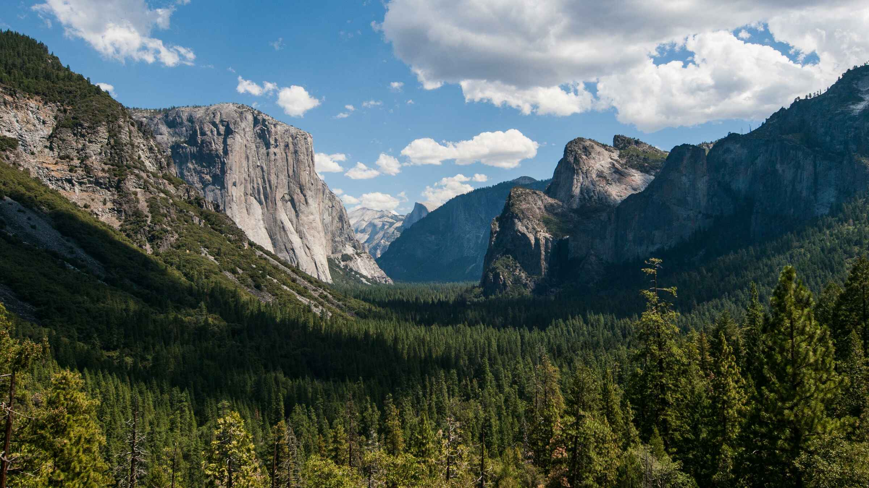
This grand show is eternal.
It is always sunrise somewhere;
the dew is never all dried at once;
a shower is forever falling; vapor ever rising.
Eternal sunrise, eternal sunset, eternal dawn and gloaming,
on seas and continents and islands,
each in its turn, as the round earth rolls.
- John Muir

God of Now and Eternity,

Moment by moment and day by day, you create the wonders of the earth.
You carve canyons over eons, and mountain ranges through millenniums.
You bring a seed to bloom and fade over the course of days.

Your time surpasses our time, and your vision is broader than our own.
Give us faith to believe in your plan for the good of all your creatures.
In the years and moments of our lives,
Give us eyes to see your beauty and wonder,
and resolve to act with love for the good of all. Amen.

