“Even now, says the Lord, return to me with your whole heart; for I am gracious and merciful.” Joel 2:12-13
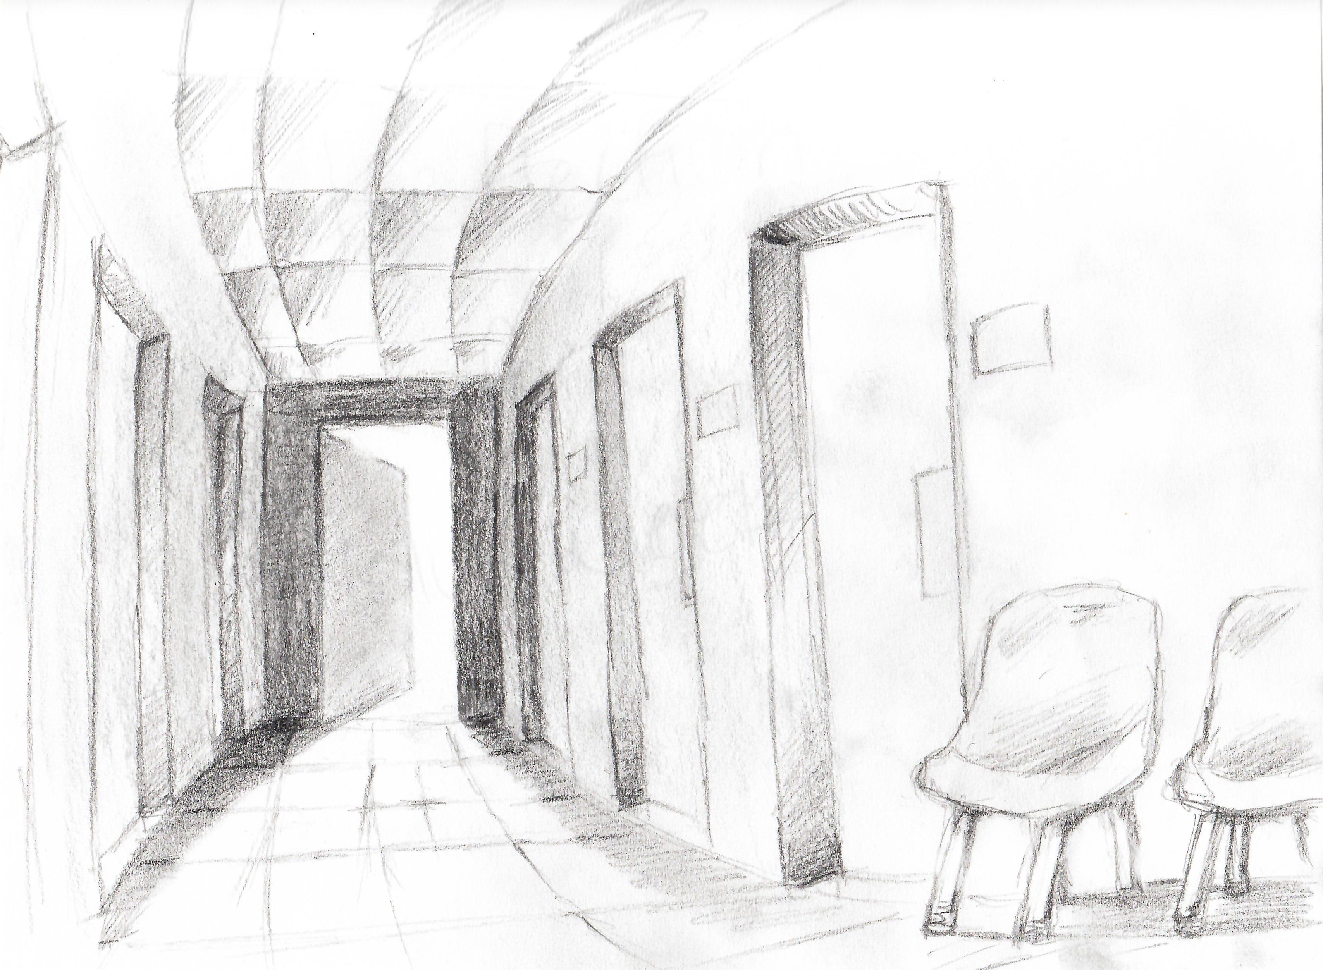
In our ministry we have entire rooms dedicated to the experience of waiting: waiting to see a doctor, waiting for test results, waiting for a loved one to come out of surgery, waiting for birth. At any given moment, in a hospital waiting room, a grandparent waits with bated breath for the arrival of their grandchild while, a few seats down, an adult child awaits the outcome of surgery being performed on their aging parent. At any given moment, in a hospital waiting room, life and death hang in delicate balance.

This week’s gospel story tells of a woman “caught in the very act of committing adultery,” and offers a similar example of how life and death hang in delicate balance. She is brought to Jesus by the scribes and Pharisees. While the law clearly requires she be stoned, they ask Jesus what to do with her. We know well his familiar response: “Let the one among you who is without sin be the first to throw a stone.” However, have we thought to consider how excruciating it must have been for the woman – face down in the dirt – waiting to see if stones would be thrown?

The season of Lent offers similar juxtaposition amid a period of waiting: we wait for the winter cold to dwindle and anxiously look for the spring sun to lure us out of hibernation, while, liturgically, Jesus awaits his painful journey to the Cross only to be resurrected on Easter Sunday. Indeed, we are utterly immersed in the dichotomous experience of waiting. Not only this, any of us who have even waited for anything know also how torturously long those last few moments of waiting can feel. The moment you see a door open and a doctor begin to head your way with news of your loved one; the moment the first footsteps walked away from the woman; the moment you see the first tulip bulb begin to emerge from the defrosting ground; waiting to discover the tomb empty. Waiting can feel like an eternity.

In each of these distinctive examples, though, we know also that the last few torturous moments of waiting offer a turning point—a pivotal moment of pause that somehow points to a shift, a feeling of the beginning of something new being created within us. As we watch the doctor walk toward us with news, or as we approach the tomb of Jesus, it is the moment just before we release the breath we didn’t realize we have been holding in. Indeed, it is in this very moment, that, if we’re paying attention, we feel God calling most ardently …

How are you being called by God, even now to “return to me with your whole heart; for I am gracious and merciful.”

