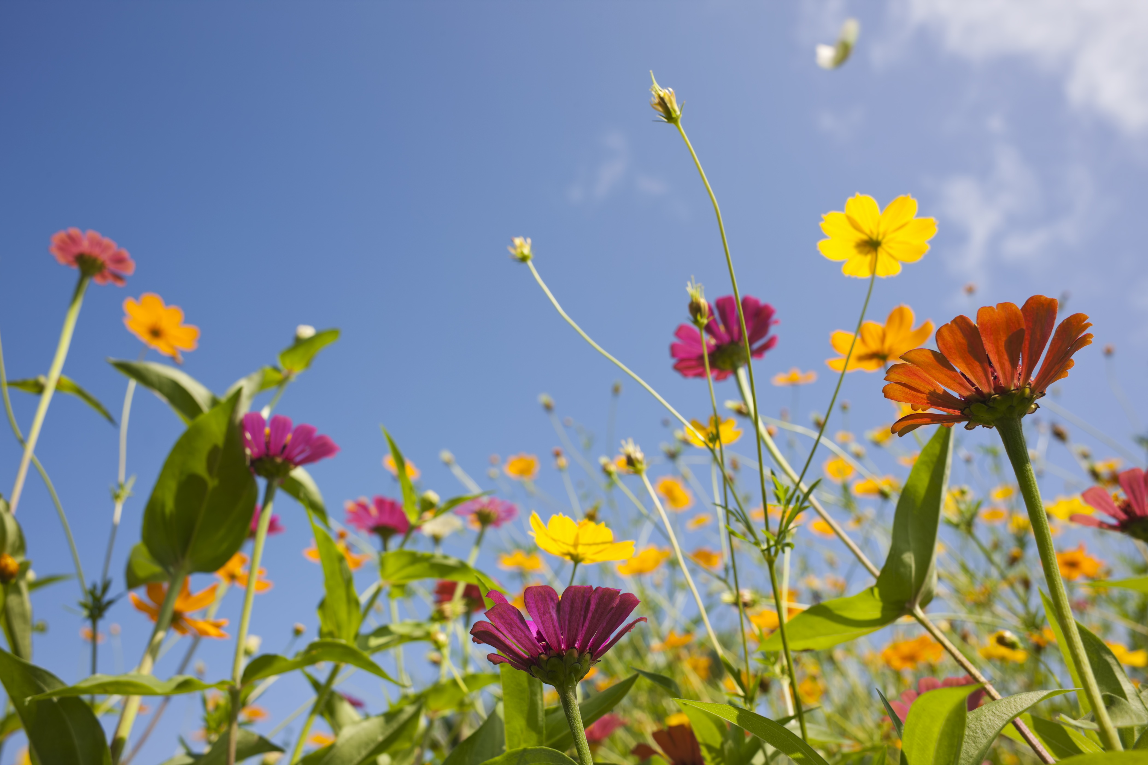
Originator of all creation, you made a world full of beauty,
an infinite expression of your glory and love for all.
Let us not forget the gift we have been given,
that we may continue to act as guardians and stewards of all your creation.
Fill us with awe and wonder today and each day as we behold your infinite creativity. Give us the courage and strength to view and engage our environment as the sacred space it is and to work to protect it from corruption and exploitation.
May we view all you have created with reverence and admiration,
that we may be reminded of your constant presence in our midst.
As we walk each day, let us remember all those who have come before and walked these same lands.
We must not forget that what we have been given is not only for us, but for the generations to come. Let us cultivate a world teeming with life, where a safe enriching environment is abundant enough for all, that God’s love and glory may shine through for generations to come.
In your name we pray, Amen.

